EITS Payment Dashboard

**Main Page**

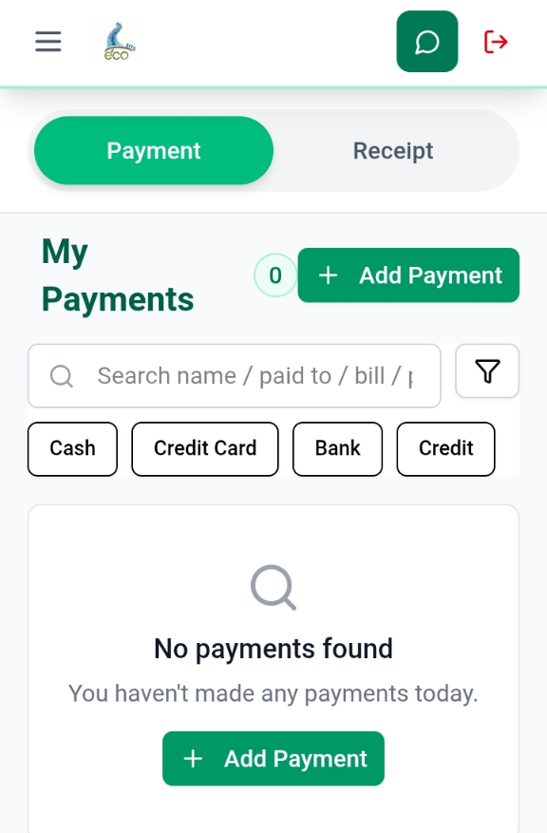

* On main page click on Payment method or click on Add Payment Button
* You can check payment history by click on payment type button.
* After that click on add payment button and this interface will appear.

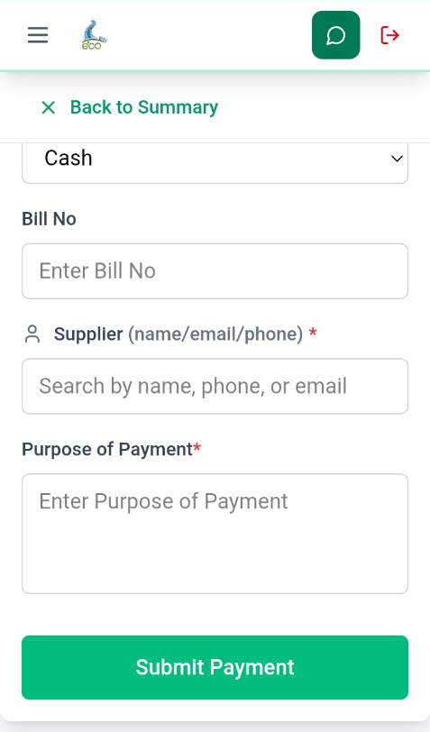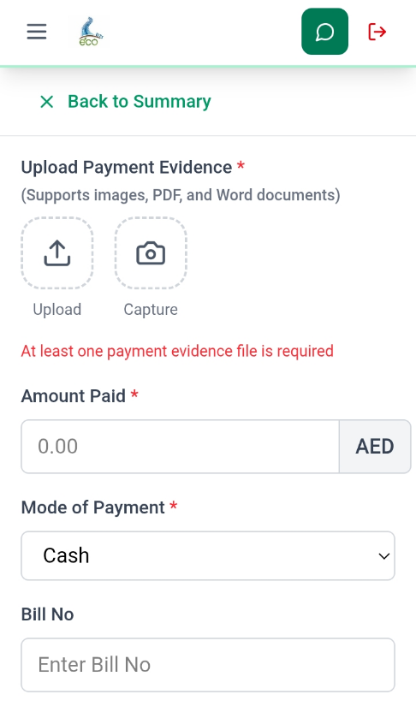

* After that upload the image of the payment slip without that it will not be saved.
* Enter the amount that you have paid.
* You can select the payment method according to your convenience.

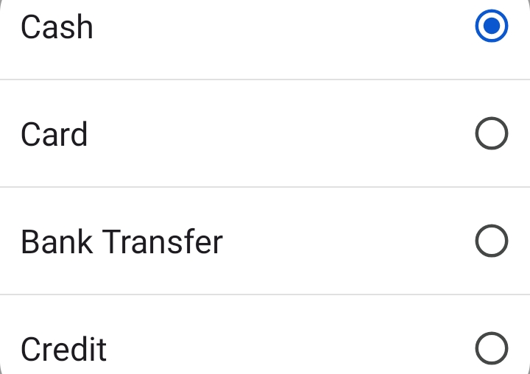

* Enter the bill number.
* You can search for the supplier’s name in the search box, and all the supplier’s details will automatically be filled in.
* Then click on submit Payment button.

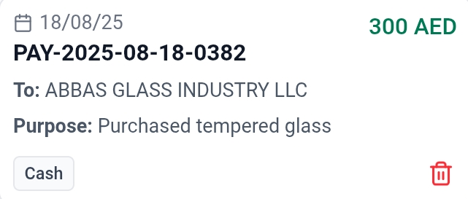

* Your final paysslip will look like this with a unique pay number

EITS Receipt Dashboard

**Main Page**

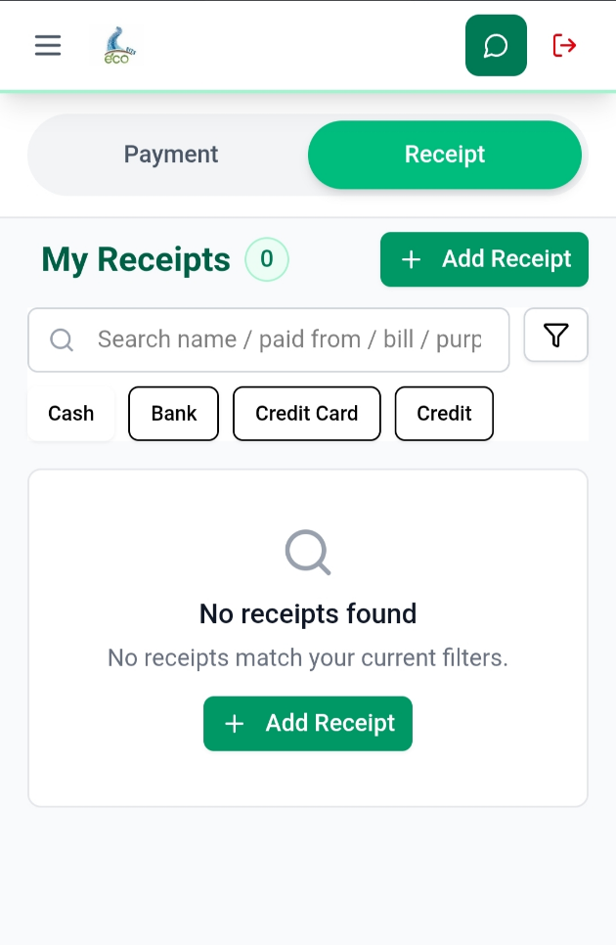

* On main page click on Receipt button and then **Add** **Receipt** Button.
* You can check receipt history by click on receipt type button.
* After that click on **Add** **Receipt** button and this interface will appear.

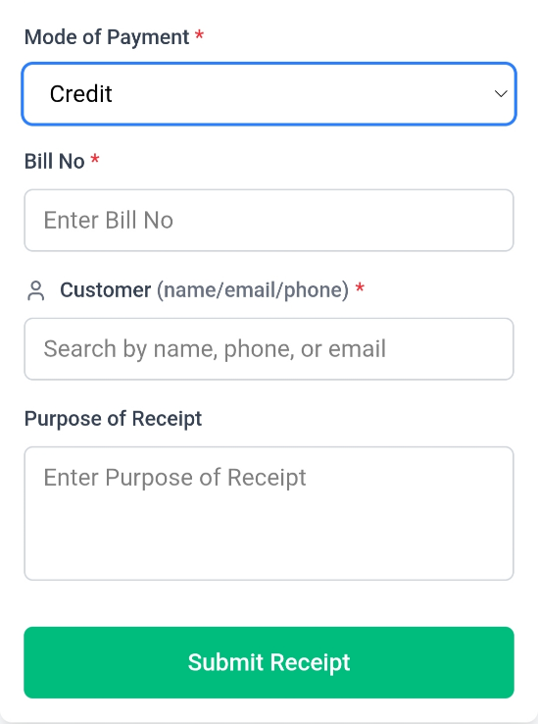

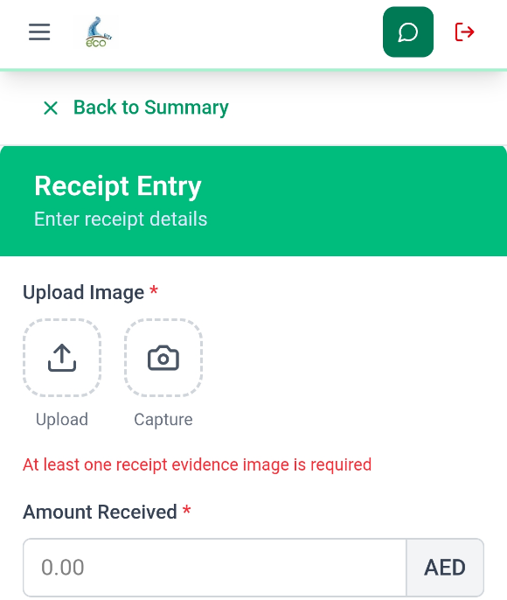

* After that upload the image of the Receipt without that it will not be saved.
* Enter the amount that you have paid.
* You can select the payment method according to your convenience.



* Enter the bill number.
* You can search for the supplier’s name in the search box, and all the supplier’s details will automatically be filled in.
* Then click on submit Payment button.

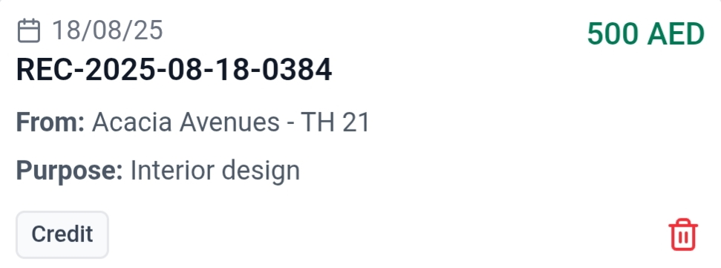

* Your final payslip will look like this with a unique pay number.

**Document Title:** EITS Payment and Receipt User Guide

* **Package Number:** 001
* **Author:** Kartik Kumar, Atul Raj
* **Approved By:** Amit Gupta
* **Created Date:** [18/08/2025]
* **Last Updated:** [18/08/2025]
* **Version:** 1.0.0
* **Status:** Draft
* **Confidentiality Level:** Internal Use
* **Developed at:** Gennext IT Management & Consulting